**How to create user and group in Unix/Linux and give root/sudo permission to users**

# useradd hydus

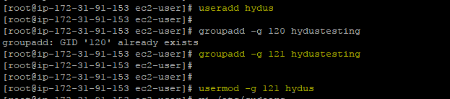

**How to create group**

#groupadd –g 121 hydustesting

Information :

here “ 121 “ is group id and “ hydustesting “is group name

**Add user(hydus) to this group(hydustesting)**

#usermod -g 121 hydus

**How to give sudo permission to specific user**

# vim /etc/sudoers.d/cloud-init 🡪 Go to this file and add below like this

hydus ALL=(ALL) NOPASSWD:ALL

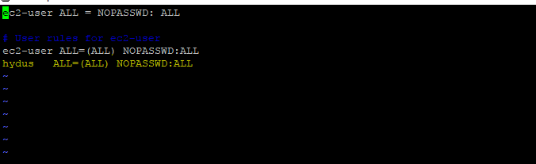

Once you add entry to this file you have sudo permission

Then you can login and check *****************************************

For more information , To check user complete information #cat /etc/passwd

To check the group information : # cat /etc/group

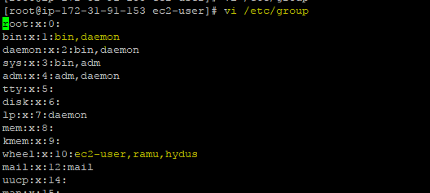

The above out put first one is groupname (wheel ) users are in yellow colour

**How to reset the password to user**

#passwd hydus

New password:

